1. Clams
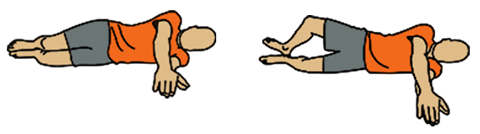
- Lie on your side with your knees bent at a 45-degree angle.
- Lift your knee by bending from the hip, Keep the heels connected.
- Lower and repeat. Your legs should look like a clamshell opening and closing.
- Do 8 reps on each side.

2. Lateral Leg Raise
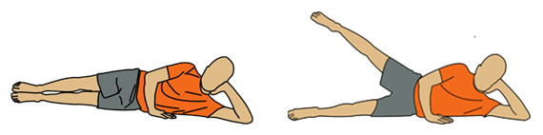
- Lie on your side with straight legs.
- Lift your leg to 45 degrees and then lower. Keep your leg straight.
- Do 5 reps with a neutral foot, 5 reps with your toe pointed toward the ground (toe in) and 5 reps with your toe pointed to the sky (toe out).

3. Donkey Kicks
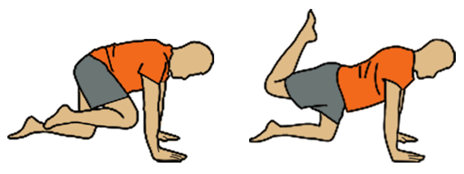
- Start in a table position (both hands and both feet on the ground).
- Bring one knee close to your chest.
- Then kick your foot back trying to make a hook over your back.
- Do 8 reps on each side.

4. Donkey Whips
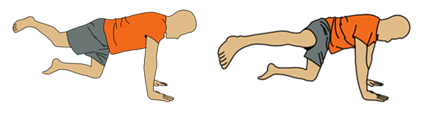
- Start in a table position.
- Extend your foot behind you without locking your knee.
- Swing your leg to the side and repeat.
- Do 5 reps with each leg.

5. Fire Hydrant
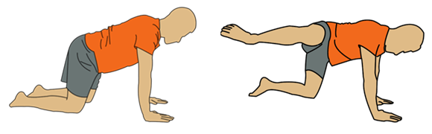
- Start in a table position.
- Lift your leg so that your knee and foot are at the same height as your back.
- Do 8 reps on each side.

6. Knee Circle, Forward
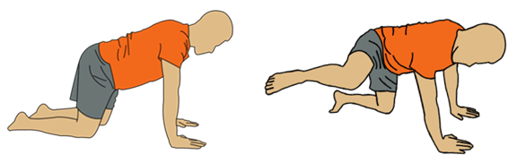
- Start in a table position.
- Lift one of your legs with your knee bent.
- Make a circular motion in forward direction (anticlockwise) with the knee.
- Do 5 reps with each leg.

7. Knee Circle, Backward
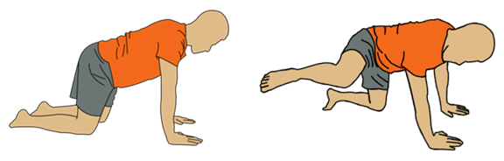
- Start in a table position.
- Make a circular motion in backward direction (clockwise) with the knee.
- Do 5 reps with each leg.

8. Hurdle Trail Leg, Forward
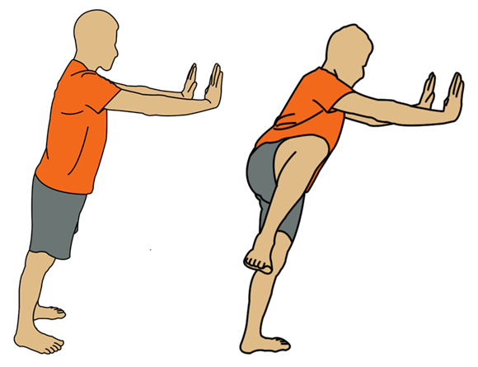
- Stand facing a wall with your hands on it. Keep your body straight.
- Stand on one leg and pretend that you are skimming your other leg over a hurdle at the hip height.
- Start with 5 reps and increase as you get stronger. Repeat with the other leg.

9. Hurdle Trail Leg, Backward
- Stand facing a wall with your hands on it. Keep your body straight.
- Stand on one leg and pretend that you are skimming your other leg over a hurdle at the hip height. But do this in the backward direction.
- Start with 5 reps and increase as you get stronger. Repeat with the other leg.

10. Lateral Leg Swing
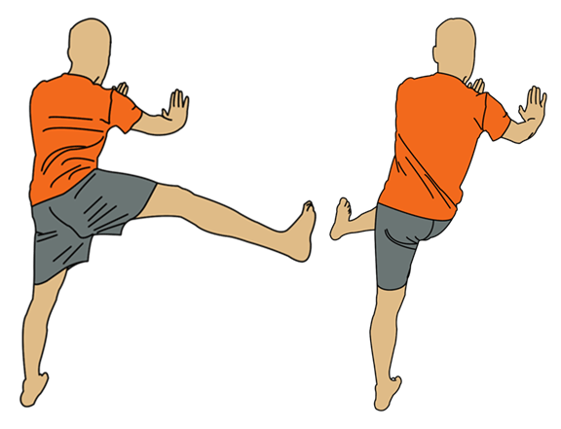
- Stand facing a wall with your hands on it. Keep your body straight and feet hip-width apart.
- Stand on your left leg and swing the right leg parallel to the wall. Your foot should reach about hip height when you swing it to the right. And the height of your left knee when you swing it to the left. Keep your swinging leg straight.
- Do 10 reps with each leg.

11. Linear Leg Swing
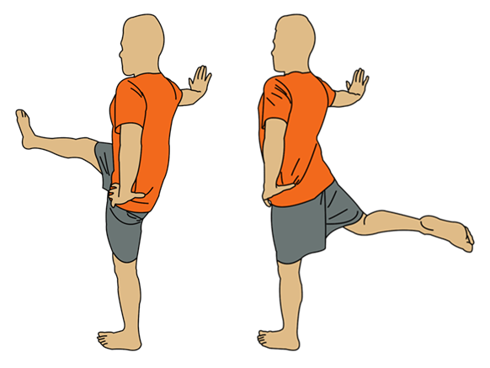
- Stand facing your one side to the wall. Keep your body straight.
- Swing your leg in front and behind you.
- Do 10 reps with each leg.

12. Linear Leg Swing, Bent Knee
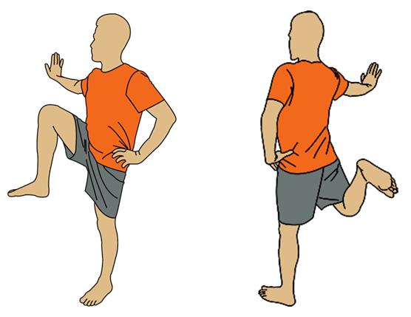
- Stand facing your one side to the wall. Keep your body straight.
- Standing on one leg, bend the knee of the other leg at a 90-degree angle.
- Swing your leg in front and behind you, keeping your knee bent.
- Do 10 reps with each leg.

