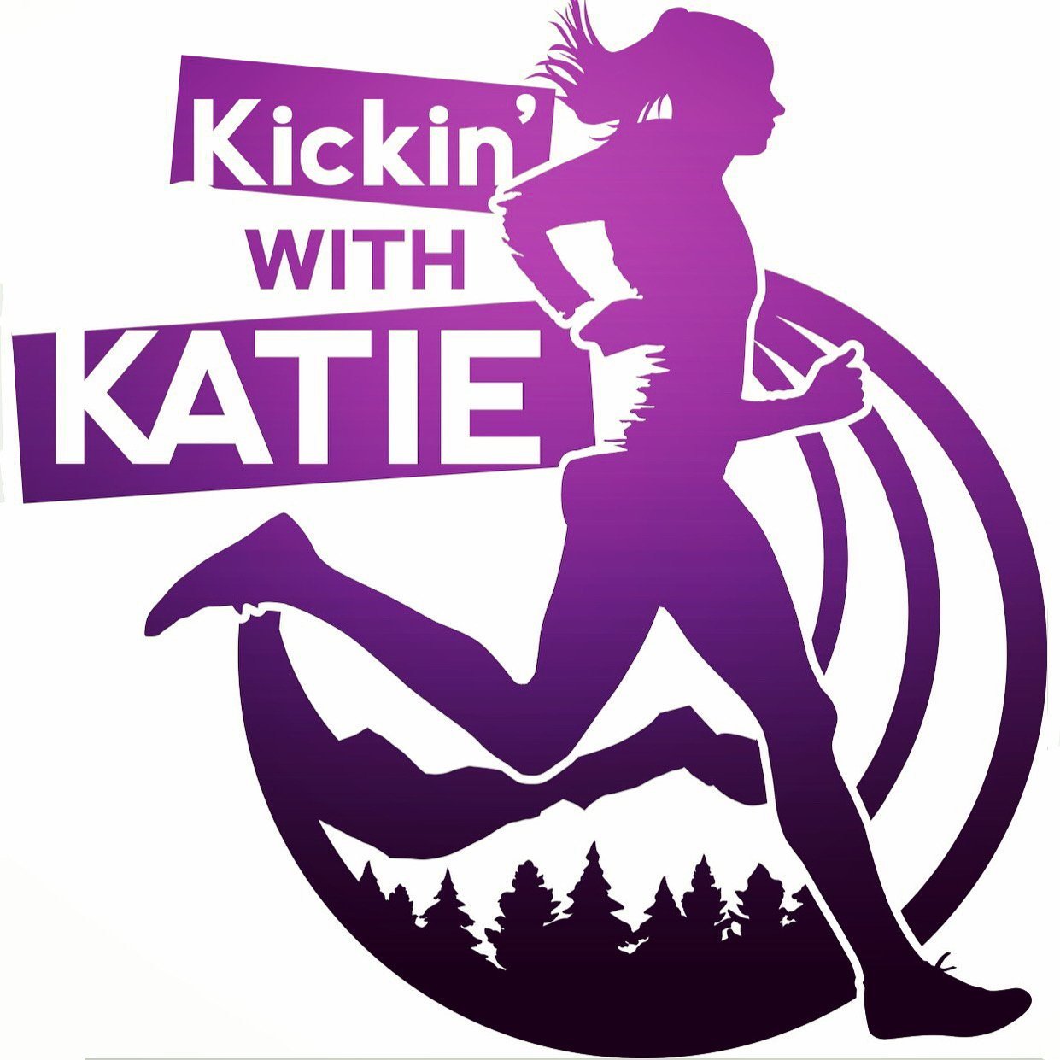  6th Annual Girls Sports Mental Skills Workshop- put some tools in your toolbox! Foothills Community Park: Boulder, June 6th, 2023  Do you get nervous to race sometimes? Do you have a hard time handling negative thoughts or self-doubt? Good news! These are skills that can be learned and practiced, just like a running workout. Join professional runners, former collegiate athletes and licensed therapists for a day of fun trail running, activities and to discuss topics that are crucial for growth, performance & long term success!  Featured Speakers:  *Monitoring Self-Talk (Professional Athlete & Counselor, Katie Follett @follettkb)  *Finding purpose and meaning in what you are doing (CFL 1 CrossFit Trainer & Counselor, Aubrey Powell)  *Properly fueling your body & maintaining a positive body image (Registered Dietician and former DI athlete, Kirsten Martin)  *Mental Resiliency (PMHNP Nurse Practitioner, Kate Powell)  *XC & Track Coach, Nikki McCauley  Heading 4 | KWK Girls Camp  www.katiefollett.com/camp  KWK Girls Camp  www.katiefollett.com/camp  KWK Girls Camp  www.katiefollett.com/camp  KWK Girls Camp  www.katiefollett.com/camp  KWK Girls Camp  www.katiefollett.com/camp  KWK Girls Camp  www.katiefollett.com/camp  KWK Girls Camp  www.katiefollett.com/camp  KWK Girls Camp  www.katiefollett.com/camp  KWK Girls Camp  www.katiefollett.com/camp  KWK Girls Camp  www.katiefollett.com/camp  KWK Girls Camp  www.katiefollett.com/camp  KWK Girls Camp  www.katiefollett.com/camp  KWK Girls Camp  www.katiefollett.com/camp  KWK Girls Camp  www.katiefollett.com/camp

